

TeamL11:fighters

1.19B21AO415 (T.Sowjanya)

2.19B21A0405(A.L.Archana)

3.19B21A0433(CH.Shanmukh)

4.196Q1A0413(I.Jyothi)

5.19JN1A0599(CH.Lakshmi)

“DEPARTMENT”

ELECTRONICS COMMUNICTION AND ENGINEERING AND COMPUTER SCIENCE

“SUBMITTED TO”

DR.KISAN NAIK

Chief innovation officer

“ Submitted on”

DECEMBER,18,2021

ACCIDENT PREVENTION PROJECT:

Introduction:

## Accidents are major cause of death and disability. In India ,there are a lot of accident taking place everyday due to mishaps as the population grows the number of cars and accidents is directly proportional. This example program shows how to find frontal human faces in an image and estimate their poses.

Procedure:

1.we’ll setup a camera that monitors stream for face in the vehicle infront of the drivers seat so that he could detect an apply facial and landmark localization to monitor the eyes. If a face is form, we apply facial land mark detection and extra the eye regions

2.now that we have the eye regions, we can compute the eye aspects the ratio in which we create a function to compute the ratio of the distance between vertical eye landmarks and horizontal eye land marks.

3.if the eye ASPECT RATIO INDICATE AN THAT EYES HAVE BEEN CLOSED FOR AN SUBSIANTLY SMALL AMOUNT OF TIME,THE DRIVER WILL SOUND AN ALARM

4.WE ARE USING THE APPLICATION OF MACHINE VISION AND IMAGE PROCESSING FOR THIS PURPOSE WITH THE USE OF OPEN CV,DLIB,PYTHON AND ML TWO IMPLEMENT AND RUN OVER ALAGORITHM.WE ARE USING SCIPY PACKAGE ALSO FOR THE EUCLIDEAN DISTANCE BETWEEN FACIAL LAND MARK POINTS IN THE EYE ASPECT RATIO CALUCLATION.

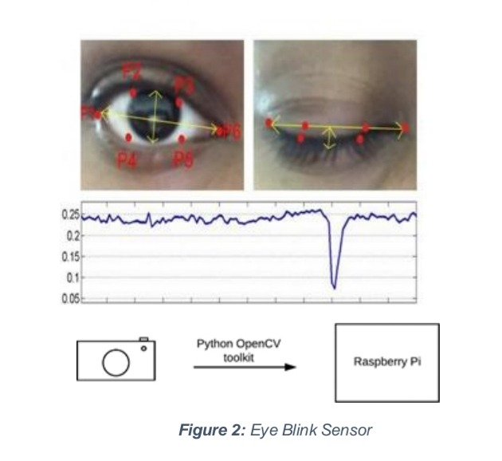

TECHNOLOGY USED:

1.PYTHON

2.OPEN CV:OPEN SOURCE COMPUTER VISION LIBRIARY IS AN OPEN SOURCE COMPUTER VISION AND MACHINE LEARNING SOFTWARE LIBRARY.A COMPUTER VISION SYSTEM CAN DETEDT THE FACIAL EMOTIONS AND DETECTION OF EYE AND MOUTH OUTLINERS IN A REAL TIME VIDEO STREAM AN THEN ALERT THE DRIVER BY PROMTING AN ALARM

3.DLIB:DLIB IS A GENRAL PURPOSE CROSS PLATFORM LIBRARAY WRITTEN IN THE PROGRAMMING LANGUAGE.

4.SHAPE DETECTOR 68 FACE LANDMARK

REQUIRED LIBRARIES:

>>PIP INSTALL-R REQUIREMENTS.TXT

GO TO SRC FOLDER

>>CD SRC

EXECUTE APP FILE

>>PYTHON APP.PY

ADVANTAGES:

1.WHEN EITHER NO FACE IS DETECTOR CALCULATED ASPECT RATIO IS LESS THAN OR EQUAL TO THE THRESHOLD VALUE,NOTHING WOULD BE DISPLAYED.

2.WHEN MOUTH ASPECT RATIO IS GREATER THAN MOUTH THRESHOLD VALUE,NOTIFICATION FOR ‘YAWING’ WOULD BE DISPLAYED.

3.WHEN EYES ASPECT RATIO IS GREATERTHAN EYES THRESHOLD VALUE,NOTIFICATION FOR ‘SLEEPING ’ WOULD BE DISPLAYED.

DISADVANTAGES:

1.IN SOME ASSEPTS IT MIGHT NOT BE WORK.

FLOW CHART:

THE VEHICLE ACCIDENT PREVENT SYSTEM USING WIRELESS TECHNOLOGY EYE BLINK AND SENSOR BARKING SYSTEM IS REPRESENTED BY THE LOGICAL MODEL OF DESIGN.

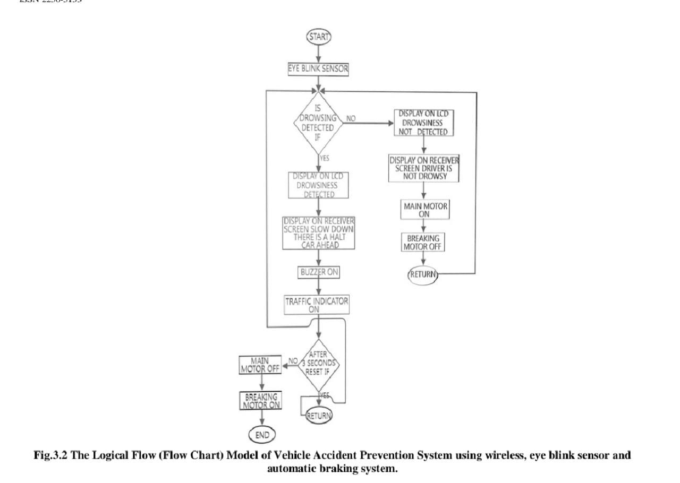

BLOCK DIGRAM:

THE VEHICLE ACCIDENT PREVENTION SYSTEM USING WIRELESS TECHNOLOGY AND EYE BLINK SENSOR AND AUTOMATIC BARKING SYSTEM OF THE DESIGN IS REPRESENTED BY THE BLOCK DIGRAM

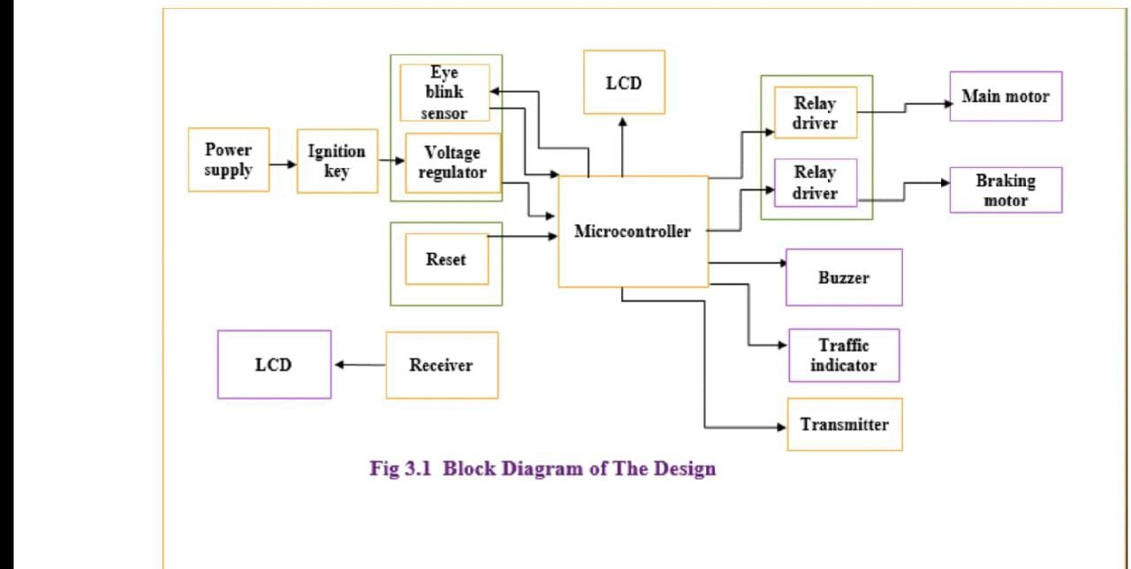

Code:

Import os

import imutils

import dlib

import cv2

from imutils import face_utils

from scipy.spatial import distance

from utilities import eye_aspect_ratio,mouth_aspect_ratio

def _init_():

eyethresh=0.25

mouththresh=0.60

frame_check_eye=5

frame_check_mouth=5

detect=dlib.get_frontal_face_detector()

predict=dlib.shape_predictor("../model/shape_predictor_68_face_landmarks.dot")

(lstart,lend)=face_utils.FACIAL_LANDMARKS_68_IDXS["left_eye"]

(rstart,rend)=face_utils.FACIAL_LANDMARKS_68_IDXS["right_eye"]

(mstart,mend)=face_utils.FACIAL_LANDMARKS_68_IDXS["mouth"]

cap=cv2.VideoCapture(0)

flag_eye=0

flag_mouth=0

while True:

ret,frame=cap.read()

frame=imutils.resize(frame,height=800,width=1000)

gray=cv2.cvtcolor(frame,cv2.COLOR_BGR2GRAY)

subjects=detect(gray,0)

for subject in subjects:

shape=predict(gray,subject)

shape=face_utils.shape_to_np(shape)

leftEye=shape[lstart:lend]

rightEye=shape[rstart:rend]

mouth=shape[mstart:mend]

leftEar=eye_aspect_ratio(leftEye)

rightEar=eye_aspect_ratio(rightEye)

ear=(leftEar+rightEar)/2.0

leftEyehull=cv2.convexHull(leftEye)

rightEyehull=cv2.convexHull(rightEye)

mar=mouth_aspect_ratio(mouth)

mouthhull=cv2.convexHull(mouth)

cv2.drawContours(frame,[leftEyehull],-1,(0,255,0),1)

cv2.drawContours(frame,[rightEyehull],-1,(0,255,0),1)

cv2.drawContours(frame,[mouth],-1,(0,255,0),1)

cv2.putText(frame,"Eye Aspect Ratio:{}".format(ear),(5,50),cv2.FONT_HERSHEY_SIMPLEX,0.7,(0,255,255),2)

cv2.putText(frame,"Mouth Aspect Ratio:{}".format(mar),(5,80),cv2.FONT_HERSHEY_SIMPLEX,0.7,(0,255,255),2)

if mar>mouththresh:

flag_mouth +=1

if flag_mouth>=frame_check_mouth:

cv2.putText(frame,"**** SUBJECT IS YAWNING ****",(10,370),cv2.FONT_HERSHEY_SIMPLEX,0.7,(0,0,225),2)

else:

flag_mouth=0

if ear < eyethresh:

flag_eye+=1

if flag_eye >= frame_check_eye:

cv2.putText(frame,"**** SUBJECT IS YAWNING ****",(10,400),cv2.FONT_HERSHEY_SIMPLEX,0.7,(0,0,225),2)

else:

flag_eye=0

cv2.inshow("Frame",frame)

key=cv2.waitKey(1)&0xFF

if key==ord("q"):

break

cv2.destroyAllWindows()

cap.stop()

CONCLUSION:

EVEN THOUGH NO VEHICLES ARE SAME FROM ANY DANGER,Q FRQCTION OF THESE CAN BE AVOIDED IF THE NEEDFUL IS DONE.THERE HAVE BEEN SEVERAL EXCELLENT WORKS OF RESEACH ON THE SUBJECT OF ACCIDENT PREVENTION AND DETECTION LIKE TRACKING OF VEHICLES ARE ELECTING THE DRIVER WITH THE HELP OF LED INTEGRETORS AND ALARMS.AN EXTENSIVE SURVEY REVIEW WILL ALLOW US TO TAKE A LOOK AT THE CURRENT AN UPCOMING TECHNOLOGIES.WHILE COMING TO THESE PROJECT IT CREATES A SYSTEM T

HAT EFFECTIVELY WORKS AT A LARGE SCALE.

REFERNCES

